Tedburn St Mary Long Term Curriculum Map 2021-2023
 | Autumn | Spring | Summer
Reception & Year 1 | Marvellous Me! | To Infinity and Beyond/A walk on the wild side | We’re Going on a Journey  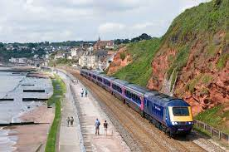
Hook or visit | Visitors to school | Zoo trip | Train Journey
Year 2 & 3  A | Stuck Between a Rock and Hard Place  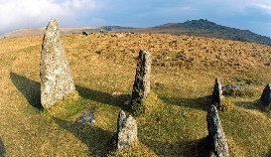 | Frozen Kingdoms | Heroines
Hook or visit | Dartmoor | Zoo/Eden Project | Visitor
Year 2 & 3  B | Blue Abyss  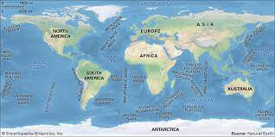 | Off with her Head! | The Empire strike back!  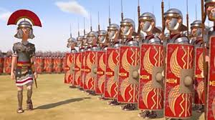
Hook or visit | Met Office visitor | Tudor Visitor | Roman Day
Year 3 & 4  A | Up the Chimneys and down the Mines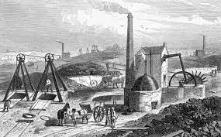 | All around the World | Rain Forest Rescuers
Hook or visit | Morwellham Quay | Visitors | Eden Project
Year 3 & 4  B | Greek Warriors 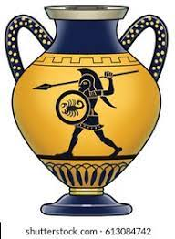 | Bon Voyage | What did the Romans Ever do for us? 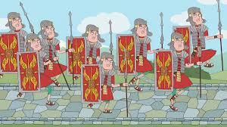
 | Greek Day | Visitor | Roman Day
Year 5 & 6  A | Surviving The Blitz  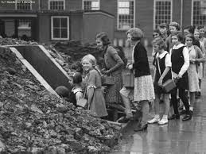 | Vicious Vikings  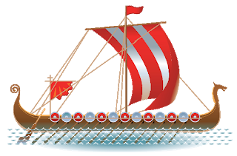 | A Cure for the Black Death?
Hook or visit | WWII Day | Visitor | Plague doctor visit
Year 5 & 6  A | What role did the Nile play in Ancient Egypt?  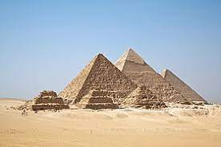 | Angry Aztecs  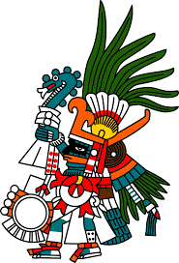 | Slaver, Suffrage and salvation
Hook or visit | Dartmoor visit | Aztec Day | Museum Visit

