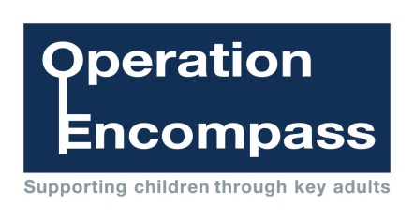

In every force, in every school, for every child

Operation Encompass is the early reporting on to schools that a child or young person has been exposed to domestic abuse